表二 Table 2 | BYWZ系列电力液压制动器  使用说明书  Operational Instruction  Of BYWZ Series Electro-Hydraulic Drum Brake  焦作市虹发制动器有限公司  JIAOZUO HONGFA BRAKE CO。 LTD。  地址(Add):焦作市虹桥工业区  HONHQIAO INDUSTRIAL ESTATE CITY  电话(Tel): 0391-7541838  传真(Fax):0391-7542897  邮编(Post code):454981
  制动器型号  Brake Type | h1  (mm) | i  (mm) | k  (mm) | d  (mm) | 安装尺寸(mm)  minimum dimension |  | 弹簧安装长度  mounting length of spring L(mm) | 制动力矩  Torque  Me(Nm)
   |  |  |  |  | H1 | Hmin | 弹簧安装长度  mounting length of spring L(mm) | 制动力矩  Torque  Me(Nm)
  BYWZ—100/18 | 100 | 40 | 220 | 13 | 333 | 326 | 50.6 | 40
  BYWZ—150/25 | 140 | 60 | 300 | 17 | 380 | 365 | 101 | 100
  BYWZ—200/25 | 170 | 60 | 350 | 17 | 380 | 365 | 155 | 200
  BYWZ—300/25 | 240 | 80 | 500 | 22 | 400 | 385 | 205 | 320
  BYWZ—300/45 | 240 | 80 | 500 | 22 | 490 | 465 | 180 | 630
  BYWZ—300/90 | 240 | 80 | 500 | 22 | 590 | 560 | 174 | 800
  BYWZ—400/45 | 320 | 130 | 650 | 22 | 490 | 465 | 330 | 1000
  BYWZ—400/90 | 320 | 130 | 650 | 22 | 610 | 560 | 302 | 1600
  BYWZ—400/125 | 320 | 130 | 650 | 22 | 765 | 700 | 306 | 2200
  BYWZ—400/180 | 320 | 130 | 650 | 22 | 765 | 700 | 306 | 2200
  BYWZ—500/90 | 400 | 150 | 760 | 22 | 610 | 560 | 326 | 2500
  BYWZ—500/125 | 400 | 150 | 760 | 22 | 765 | 700 | 305 | 3150
  BYWZ—500/180 | 400 | 150 | 760 | 22 | 820 | 775 | 292 | 3550
  BYWZ—600/90 | 475 | 170 | 950 | 26 | 593 | 565 | 387 | 3200
  BYWZ—600/125 | 475 | 170 | 950 | 26 | 748 | 700 | 360 | 4000
  BYWZ—600/180 | 475 | 170 | 950 | 26 | 843 | 775 | 344 | 5000
  BYWZ—700/180 | 550 | 200 | 1080 | 34 | 840 | 768 | 286 | 8000
  BYWZ—800/180 | 600 | 240 | 1240 | 34 | 829 | 771 | 492 | 10000
  BYWZ—800/320 | 600 | 240 | 1240 | 34 | 887 | 815 | 497 | 12500
□ Working Principle  The electro-hydraulic drum brakes of the series is composed by two parts of the match the brake frame and the flameproof BYT1 power hydraulic pusher. When energized, the electro-hydraulic pusher action putter rapidly rising, and leverage open brake shoes; When powered down, the electro-hydraulic pusher putting down quickly in the spring force, and through leverage the brake shoes close up.  □ Installation and adjustment of the brake  ○Brake installation:  ⑴Vertical loading: Loosen the nut 4,5, main spring in a free state, loosen the nut 7, turn the screw 6 softened brake arm, then brake package on the brake wheel;  ⑵Transverse: when the brake wheel has been installed between the motor and other mechanical, loosening nut 4,5,7 turning the screw 6, to remove the screw 3 and 6, the brake arm tipped, from the side mounted to the t brake wheel;  ○The adjustment of the brake:  ⑶Pusher’s adjustment of the working stroke  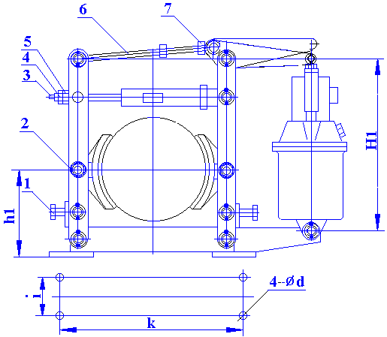  In the case of guaranteed minimum brake shoe back distance, the better the working stroke of the smaller of the pusher, so the need to adjust the mounting height of the pusher H1, and its adjustment method: loosen the nut 7, the rotation of the screw 6, so that the installation dimensions H1 found table II requirements. then tighten the nut 7.  ⑷Braking torque adjustment  Loosen the nut 4, clamped the tail square head of the screw 3, turn the nut 5, the main spring installed length L comply with the provisions of Schedule II, adjust, tighten the nut 4,5; | ⑸Brake shoes retire from the adjustment  When the brake shoe is opened to adjust the brake shoe retreat distance adjustment bolt 1, so that the clearance on both sides of substantially consistent;  ⑹The fixed brake shoe nut 2, should be elastic appropriate, so that the brake shoe may vary bit.  □ Use and maintenance  To regularly check the working condition of the brake.  Examination should focus on the following:  ⑺Brake components movement is normal, adjust the nuts are tightened;  ⑻The pusher is working properly, whether the hydraulic oil in sufficient quantities. Presence or absence of oil spills and oil leakage phenomenon introduction of wire insulation is good;  ⑼Promote the installation size H1 shall not be less than the minimum size listed in Table 2 Hmin, in excess of the requirements to be adjusted or lose their braking effect!  ⑽Is normal brake shoes against the brake wheel on the state of the friction surface is intact, with or without the greasy stolen goods reach table 1 value when the thickness of the brake pads, brake pads should be replaced;  ⑾The brake wheel temperature should not exceed 200 ° C;  ⑿Lever and the spring found cracks should be replaced.  表一 Table 1
  制动轮直径brake drum diameter(mm) | 100 | 150 | 200—300 | 400—700 | 800
  最小厚度minimum thick of linings(mm) | 2 | 2.5 | 3 | 4 | 1
  中部厚度thickness at the middle of the linings(mm) | 2.5 | 3 | 4 | 5 | 2

